**How to withdraw money from an ATM machine**

This document explains how to withdraw money from an ATM machine. ATM is also known as an automated teller machine. This machine allows their users to withdraw money very quickly and conveniently.

To withdraw money first you must locate the ATM Machine location.

Here is the structure of an ATM machine for you better understanding

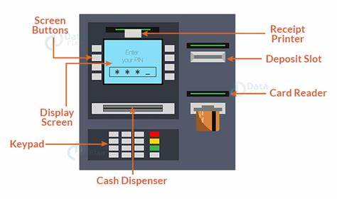

1.Insert the Debit card or ATM card in card reader, make sure while inserting card you must insert it from chip side and read the instructions appear on the screen if instruction appear like this remove your card, then remove it. If instructions appear like don’t remove your card while completing the process, then don’t remove it.

2.Select your preferred language you can select it from above shown keys or you can touch on the language.

3.after selection of language, enter your four- or six-digit pin code with the help of ATM Machine keyboard.do not share your pin with anyone. **make sure that you’re entering the correct pin. If you enter the incorrect pin 3 times, then the machine will block your card**.

4.once pin entered then select the transaction type as a withdrawal of money.

5.after selecting type of transaction, select account type if your account is saving type then select saving or if your account is current type then select current type.

6.once the account is selected, then enter the amount that you want to withdraw.

**You can withdraw the amount within the limit that has been set by your bank**.

7.once the ATM machine dispenses your cash please collect it from the cash dispenser slot.

8.collect cash receipt from receipt printer.

9.Once you collect the cash don’t forget to take your card. Place your cash and card securely in your wallet or purse.

10.**If you’re facing any kind of issue while withdrawing money, contact to your bank customer care or their bank employee don’t take help from strangers it will land you in trouble.**